

Undergraduate Lab Report

Course Title: Experiment of Computer Organization
Course No: 60080014
Student Name: 蒋云翔
Student No: 2022102330
School: 暨南大学
Department: 国际学院
Major: CST
Instructor： SUN Heng

Academic Year:2022~2023,Semester : 1st [ √ ] 2nd[ ]

Academic Affairs Office of Jinan University
Date (dd/mm/yyyy)__04/12/2023______
Computer Organization Lab List
Student Name: 蒋云翔 Student No: 2022102330

ID | Lab Name | Type
1 | Number Storage Lab | Individual
2 | Manipulating Bits | Individual
3 | Simulating Y86-64 Program | Individual
4 | Performance Lab | Team
5 | A Simple Real-life Control System | Team
6 | System I/O | Individual
Undergraduate Lab Report of Jinan University
Course Title Experiment of Computer Organization Evaluation
Lab Name A Simple Real-life Control System Instructor Sun Heng
Lab Address 116
Student Name 蒋云翔 Student No 2022102330
College 国际学院
Department Major CST
Date 04 / 12 / 2023 Morning / Afternoon
- Introduction

This lab involves in the I/O of chapter 10. Please be patient to read full instructions.

- Lab Instructions or Steps

a) For each requirement, separately provide the Boolean expressions that you decided to use.

b) Create a single combined truth table with all the available sensor inputs and actuator outputs for all the five requirements together. Some of the truth table entries will be don’t-care states (represented by an X) instead of true or false. For this sub-problem assume that these five requirements together constitute a complete system.

c) Write a C program using the Boolean logic concepts and tools learnt in class to materialize these five requirements. Use if-then-else structure to do this. Submit the C code and your executable. A basic code framework (file name “lab5.c”) for a general control system has been provided. This is available in the lab files that you downloaded. Use this code to learn how to develop C program for a real-life control system.

- Lab Device or Environment
Computer: ASUS天选3 NVIDIA3060 i7
Virtual computer: VMware pro station 17.0 Ubuntu 16.04

- Results and Analysis
The scenarios running in the virtual machine are all possible scenarios based on the requirements given by the problem.

In fact, there are many special cases that need to be taken into account. For example, whether the conditions of driver_on_seat and driver_seat_belt_fasten are inconsistent, and whether the conditions of engine_running and key_in_car are inconsistent.

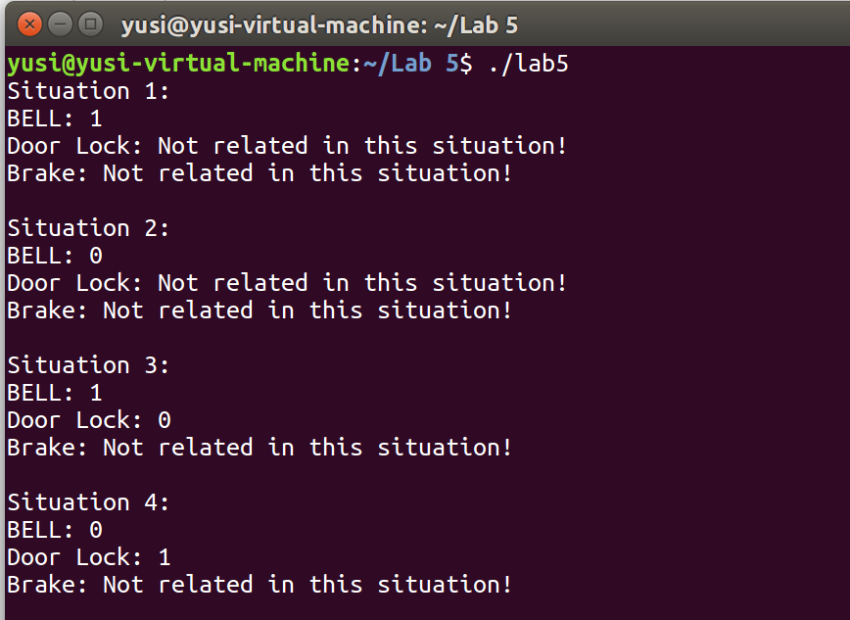
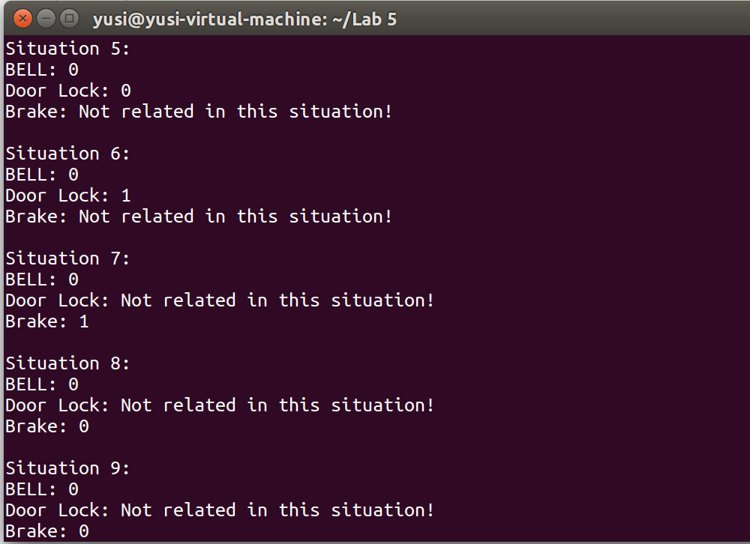
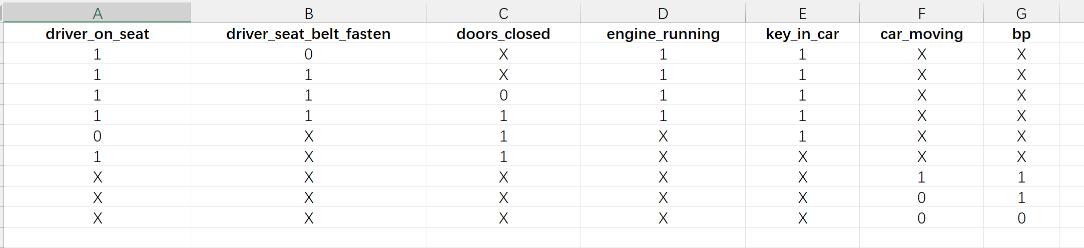

2 stands for irrelevant condition ⬇
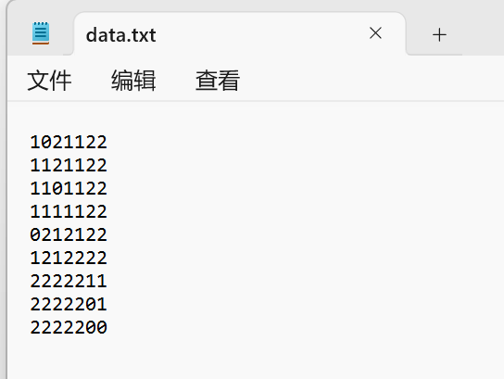
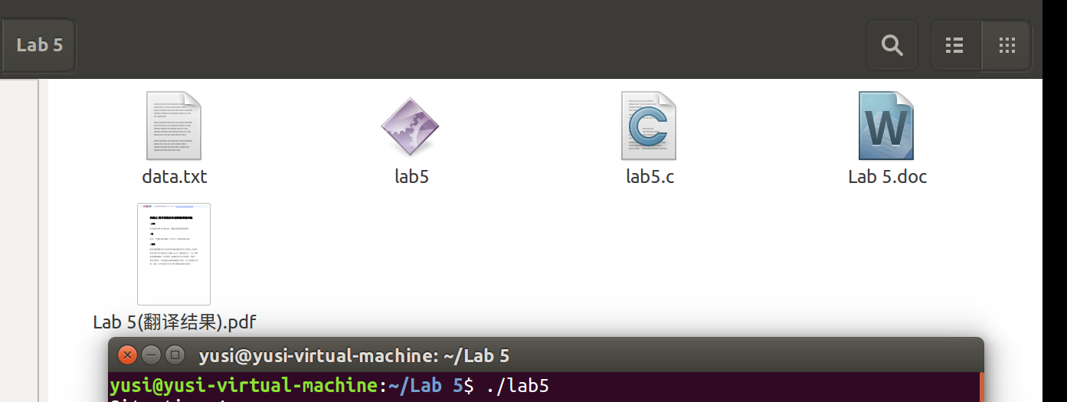
5. Appendix (Program Code)
/*
This program sounds the bell when driver is on seat AND haven't closed the doors. Use the general framework and the function shells, replace the code inside the control_action() function with your own code.

Note: This code is designed to run in an infinite loop to mimic a real control system.
If you prefer to read the inputs from a file, modify the code appropriately to terminate the loop when all the inputs have been processed.

run this file as : gcc filename.c -o executableName

*/

#include <stdio.h> //This is useful to do i/o to test the code
#include<stdlib.h>

unsigned int driver_on_seat;
unsigned int driver_seat_belt_fasten;
unsigned int doors_closed;
unsigned int engine_running;
unsigned int key_in_car;
unsigned int car_moving;
unsigned int bp;
unsigned int brake;
unsigned int bell;
unsigned int door_lock;

int currentline = 0;

void read_inputs_from_ip_if() {

char data[10];
FILE* file;
file = fopen("data.txt", "r");
if (file == NULL)
{
printf("Fail to open the file!\n");
exit(0);
}
for (int j = 0; j < currentline; j++) {
fscanf(file, "%*s");
}

if ((fscanf(file, "%s", &data) == -1)) {
exit(0); //The file had reached the end
}

printf("Situation %d:\n", currentline + 1);

for (int i = 0; i < 7; i++)
{
switch (i)
{
case 0:
driver_on_seat = (int)data[0]-48;
break;
case 1:
driver_seat_belt_fasten = (int)data[1] - 48;
break;
case 2:
doors_closed = (int)data[2]-48;
break;
case 3:
engine_running = (int)data[3]-48;
break;
case 4:
key_in_car = (int)data[4]-48;
break;
case 5:
car_moving = (int)data[5]-48;
break;
case 6:
bp = (int)data[6]-48;
break;
default:
break;
}
}
currentline++;
fclose(file);
}

void write_output_to_op_if() {

printf("BELL: %d\n", bell);
if(door_lock == 2) printf("Door Lock: Not related in this situation!\n");
else printf("Door Lock: %d\n", door_lock);
if (brake == 2) printf("Brake: Not related in this situation!\n");
else printf("Brake: %d\n", brake);
printf("\n");
}

//The code segment which implements the decision logic
void control_action() {

// Requirement 1: Alarm when the driver does not fasten the seat belt and start the engine

if (driver_on_seat && !driver_seat_belt_fasten && engine_running && key_in_car && doors_closed) {
bell = 1;
}
// Requirement 2: An alarm is sounded when the driver starts the car without closing all the doors
else if (driver_on_seat && !doors_closed && engine_running)
bell = 1;

else {
bell = 0;
}

// Requirement 3: The situation returns to normal and the bell is closed immediately
if (driver_on_seat && doors_closed && key_in_car && driver_seat_belt_fasten)
bell = 0;

// Requirement 4: Leave the door unlocked when the driver gets out of the car but the key is still in the engine and the door is not required to be locked
if (!driver_on_seat && key_in_car && doors_closed) {
door_lock = 0;
}
else if (driver_on_seat && doors_closed)
{
door_lock = 1;
}
else if(doors_closed == 2)
{
door_lock = 0;
}
else {
door_lock = 0;
}

// Requirement 5: The brakes are engaged when the brake pedal is pressed, otherwise release
if (car_moving && bp) {
brake = 1;
}
else if (car_moving && !bp) {
brake = 0;
}
else if (!car_moving) {
brake = 0;
}
else if (bp == 2) {
brake = 0;
}
else brake = 0;

// Determine whether it is irrelevant condition (use 2 for irrelevant)
if (doors_closed == 2)
{
door_lock = 2;
}
if (car_moving == 2) {
brake = 2;
}
}
/* --- You should not have to modify anything below this line ---------*/

int main(int argc, char* argv[])
{
/*The main control loop which keeps the system alive and responsive for ever,
until the system is powered off */
for (; ; )
{
read_inputs_from_ip_if();
control_action();
write_output_to_op_if();
}
return 0;
}

